ELT-3050 Final Project

5/1/21

Kevin Kunker, Josh Remillard

**Preliminary Design Proposal**

**Overview:**

The purpose of this this project is to produce an arbitrary waveform generator (AWG). AWG’s can synthesize a general selection of waveforms usually ranging from sine, square, or triangle patterns.

They can also produce waveforms which are custom tailored to meet certain criteria an end user may require.

**Scope of project:**

An AWG will be created using the FRDM-KL25Z development board, along with the accompanying VTC shield board. The AWG will have the ability to generate three pre-defined waveforms, as well as two user specified arbitrary waveforms. The AWG will have four selectable output frequencies, each having a maximum voltage output of 3.3 volts. AWG functionality will be controlled via serial communication using predetermined commands.

**Project Design:**

The initial design for the AWG consists of both hardware peripherals, and source code incorporated into a Free RTOS environment.

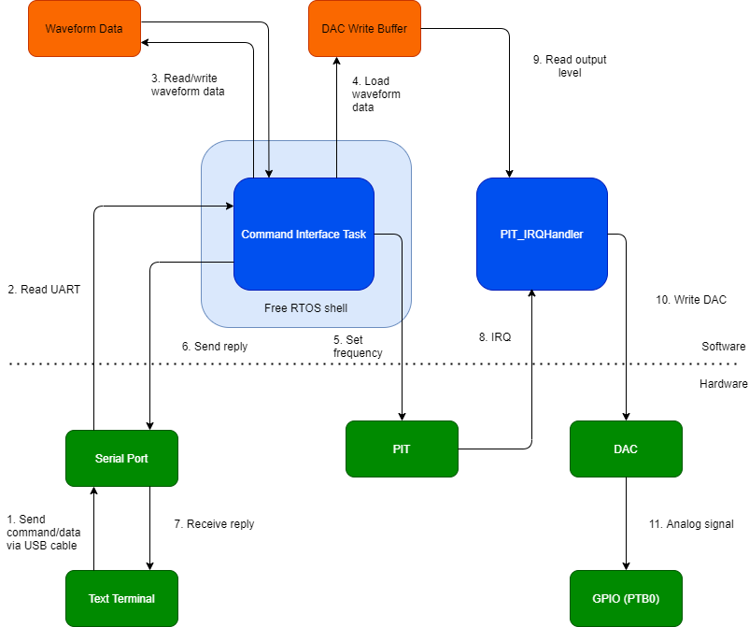

**Figure I: Block Diagram of AWG**

The AWG shall be controlled by a serial terminal such as TeraTerm which can send commands and arbitrary waveform data to the microcontroller. The commands/data travel via a USB cable to the Open SDA port on the KL25Z.

The Command Interface Task is a task created in the main function using FreeRTOS, so that other possible tasks can run concurrently. It processes commands, reads/writes waveform data, and sets the PIT value. The Command Interface Task also has the important function of controlling which DAC read buffer the PIT_IRQHandler will pull data from. The task will also write waveform data to a second DAC write buffer to allow for seamless switching between waveforms. Using dual DAC write buffers will allow the Command Interface Task, and the PIT_IRQHandler to ping pong between buffers.

The PIT_IRQHandler is the KL25Z’s standard ISR for the PIT. In this case, it is used to set the DAC output at a particular frequency. Once triggered by the PIT, this interrupt reads one integer in the DAC write buffer at the current index. The interrupt will then write the level to the DAC, and update the index. The index starts at 0 and wraps back to 0 once the end of the write buffer is reached.

When the DAC value has been set, it will output an analog value to the SERVO 3 Header on the shield board.

The PIT_IRQHandler will also output a sync waveform on PTB0, which runs concurrent to the output waveform on the SERVO 3 header. The sync signal will match the low to high output of the waveform, then toggle from high to low at 50% of the waveform period.

**Project Timeline:**

This proposal will be presented for review on 05/01/2021. Upon approval, a functional prototype will be developed for a final review with an anticipated date of 05/12/2021. Any necessary revisions will be made at that time. The finished AWG, including documentation will be submitted 05/21/2021.